22 février 2018

epita

sushant ATTADA

SRUJAN KASANDULA

IDENTITY INFORMATION MANAGEMENT USER UNDERSTANDING DOCUMENT

COMPLETE PROJECT

Table of Contents

1. Purpose 3

2. Introduction 3

3. Flow chart 3

3.1.1 Login 3

3.1.1 User creation 3

4. User Details 3

4.1. User creation 3

4.1. User updation 3

4.1. User deletion 3

# Purpose

* The purpose of the document is to make the user understand the project Identity Management System

# Introduction

* This project help is saving users information i.e., User name, password and Display name. We have performed identity information systems in two ways:

1. Via Console,
2. Via Servlets.

# Flow Chart

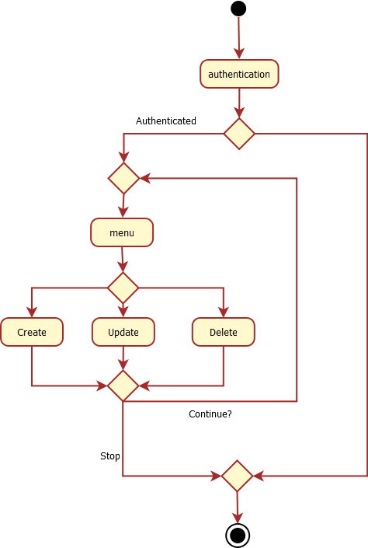

## Login

* User can login with his unique credentials.
* This is for the authentication of the application.

**Login with Console:**

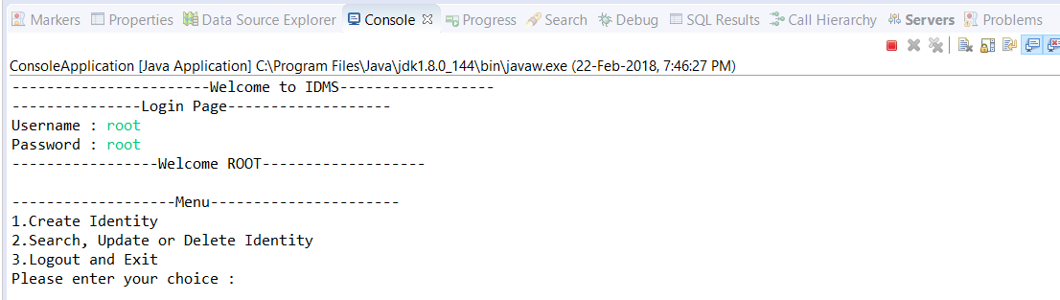

**Login with Servlets:**

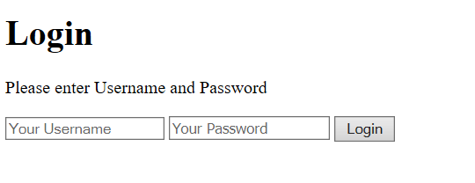

## User Creation

* For to login, user needs a user name and password, so he can create a user name and password
* The creation option comes when only the user gives wrong credentials.
* User can choose a user name and password and will be navigated to the login page again if successfully created.

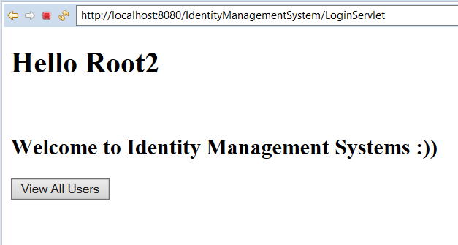

# Identity details

* Each UserID is unique for each user.
* A User details contains name, password and display name.
* Any new user can be created in the identity system only if a user is logged in
* User name and Display name are alpha numeric strings 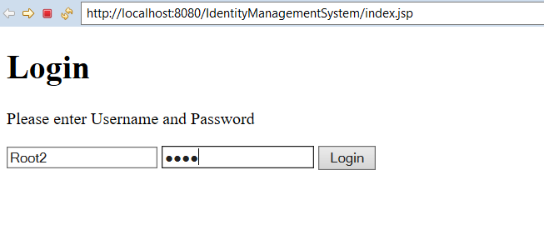

## Contact Creating, updating and deletion

* Any user can be updated after creation or later.
* A user can be updated using its given unique id.
* All the fields like Name, Password and Display name can be updatable.
* Deletion of contact is different from deletion of user credentials.
* There is no asking of are you want to delete the contact before deleting.
* So, user has to be careful before deleting.

This is the existing users list. Press on “ADD NEW USER”

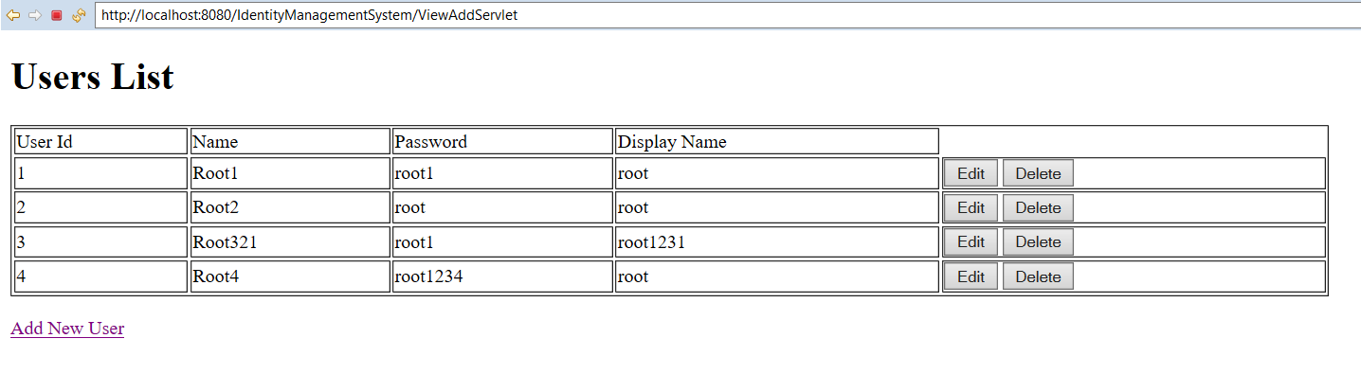

## Creating the new USER:

Upon press on “Add New User”. New User screen pops out. Here we can give the new user details.

With Console:

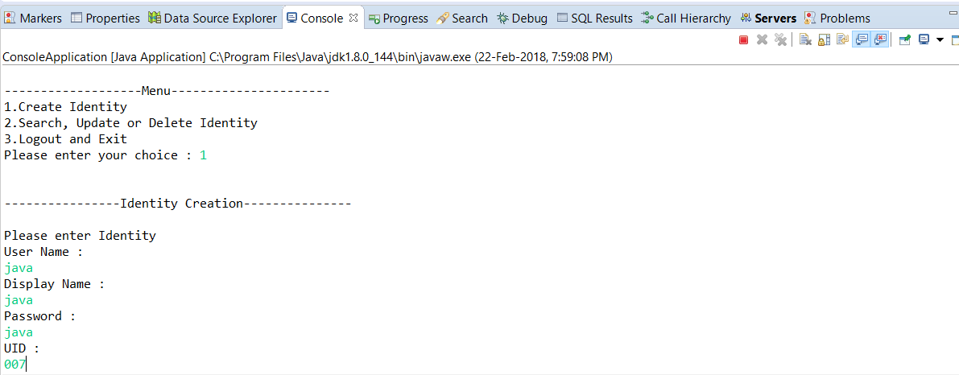

With Servlets:

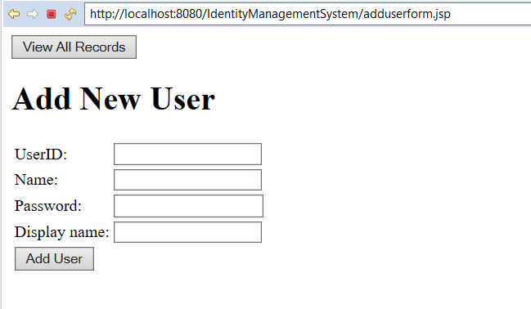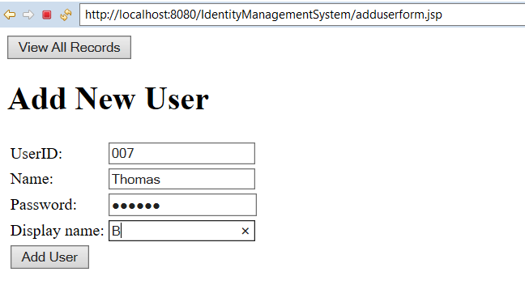

After adding the user, the console shows that the user record is successfully inserted/saved.

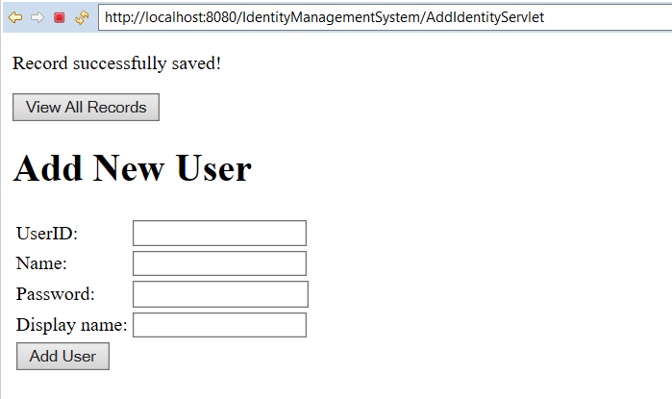

Now, you can see the updated user list. With the new entry.

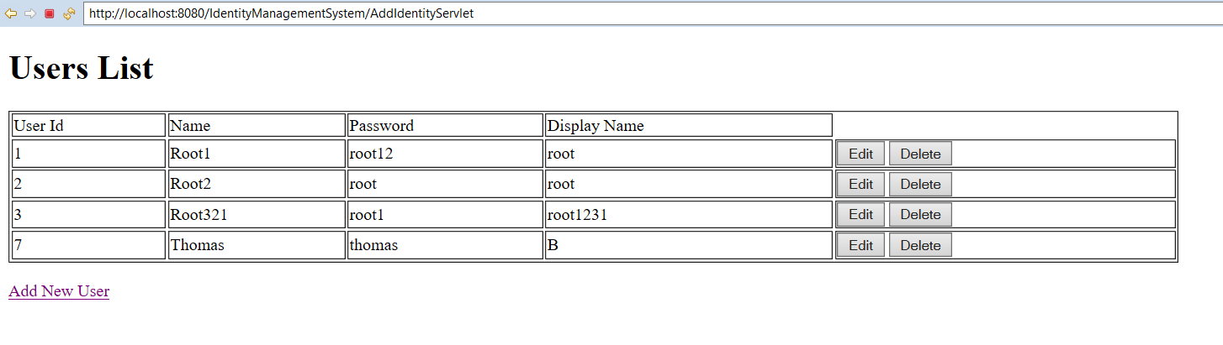

## Edit the existing User from User List:

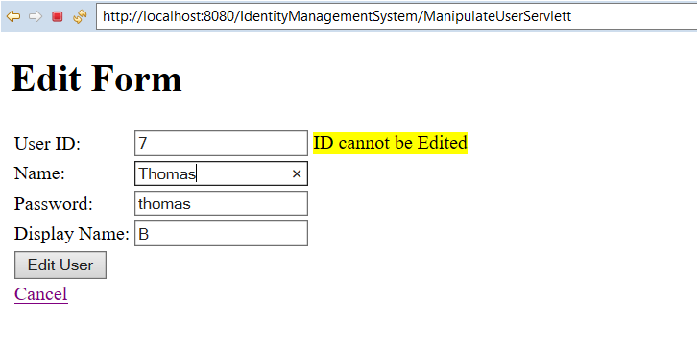

## After updating the User Name:

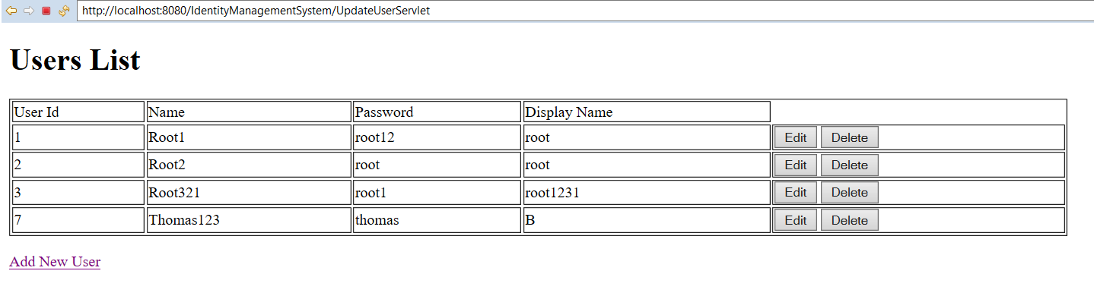

**Update the record with Console:**

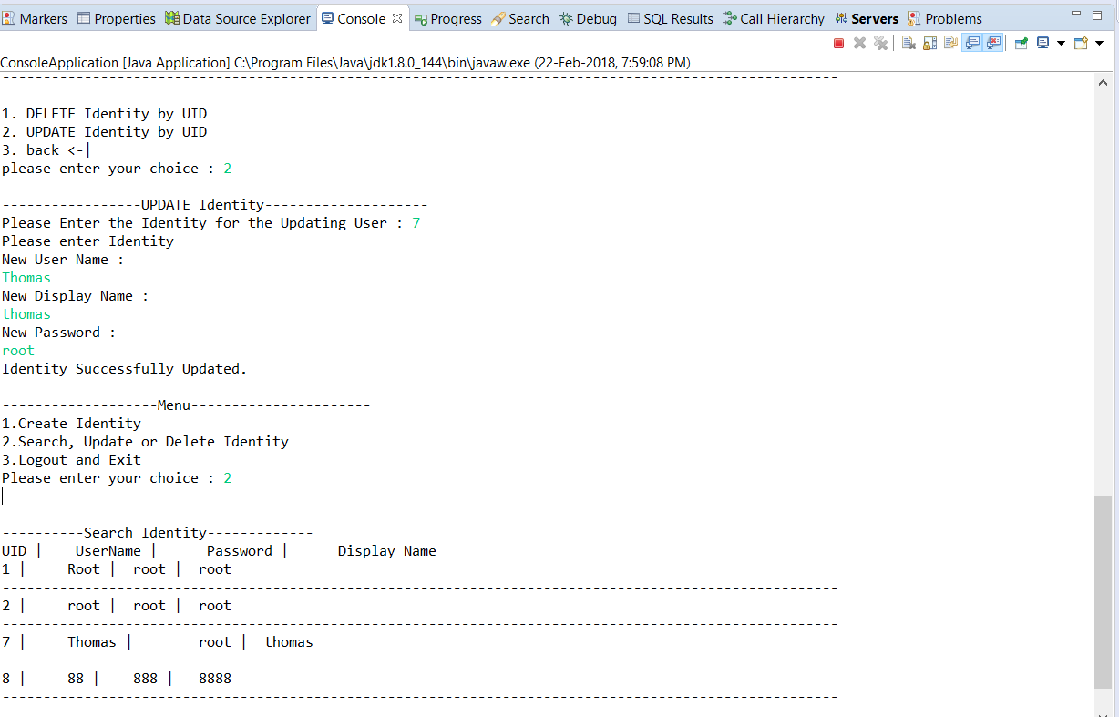

## Deletion of selected record from the User List.

With Console:

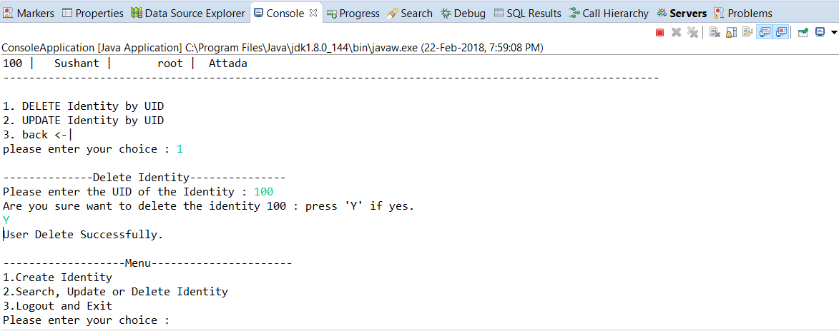

With Servlets:

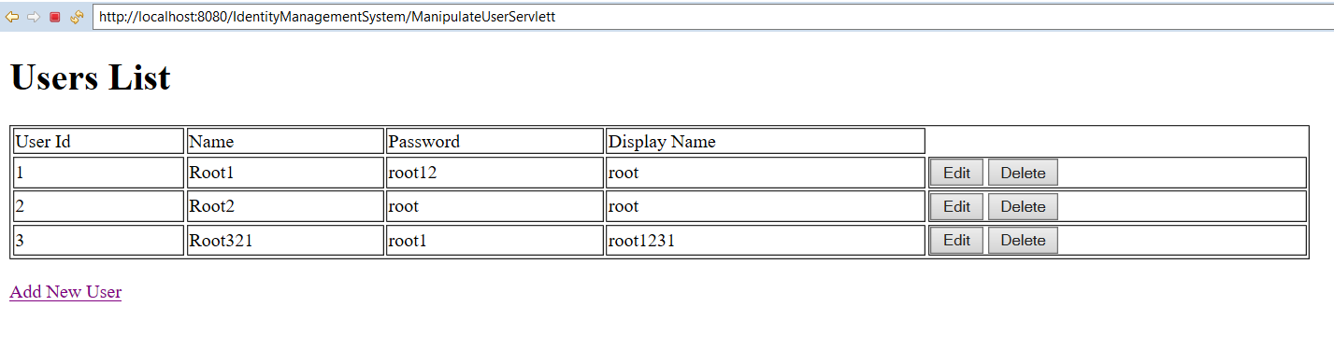Coming out the application:

